I. Introduction & Core Concepts
Apache Kafka is a distributed event streaming platform used for:
- Real-time data pipelines and streaming applications.
- Common Uses: Real-time analytics, event streaming, log aggregation, and microservices communication.
- Key Advantage: It is faster than traditional messaging systems because of sequential disk writes, page cache usage, zero-copy transfer, and message batching.

II. Kafka Architecture & Components
Kafka's scalability relies on its distributed architecture.
- Main Components:
  - Broker: The Kafka server that stores messages.
  - Producer: Sends messages to topics.
  - Consumer: Reads messages from topics.
  - Controller Broker: Responsible for leader election, partition management, and cluster monitoring.
- Logical Structure:
  - Topic: Logical channel for message storage.
  - Partition: Divisions of a topic for parallel processing and scalability.
  - Offset: A unique number assigned to each message within a partition.

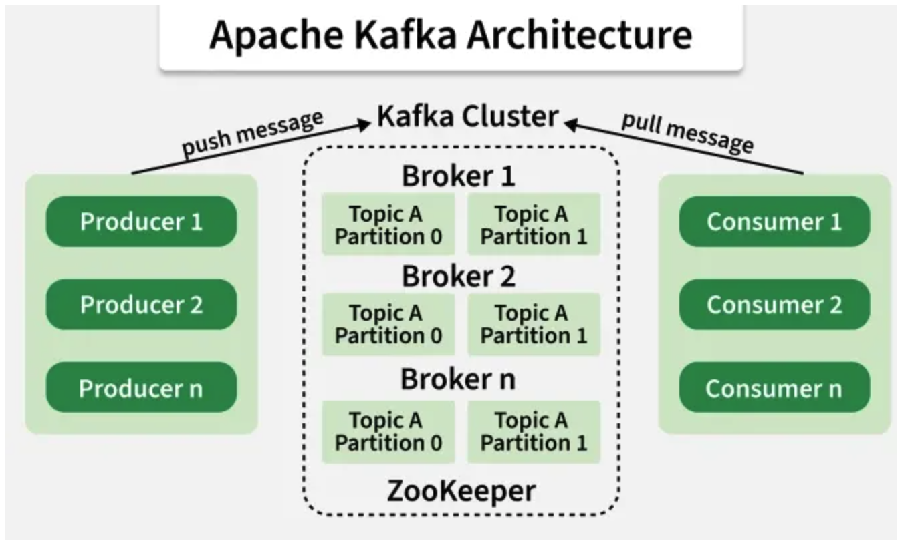

III. Producer & Data Distribution
Producers decide how data is distributed across partitions using several strategies:
- Key-Based Partitioning: Uses $partition = hash(key) \% number\_of\_partitions$. This ensures messages with the same key go to the same partition, preserving order.
- Round Robin: Used if no key is provided to distribute messages evenly.
- Custom Partitioner: Developers define their own routing logic (e.g., by region).
- Explicit Assignment: Producer chooses the partition directly.
Producer Acknowledgements (acks):
- acks=0: No confirmation.
- acks=1: Leader confirms.
- acks=all: All replicas must confirm.

IV. Consumer Behavior & Scaling
- Consumer Groups: A group of consumers sharing partitions.
- The "Rule of One": One partition can only be read by one consumer in a consumer group at a time.
- Scaling Limits: Maximum consumers in a group = number of partitions. Extra consumers remain idle.
- Consumer Rebalance: Occurs when consumers join/leave or partitions increase. Kafka then redistributes partition ownership.

V. Reliability, Replication, & Ordering
- Ordering Guarantee: Kafka guarantees ordering within a partition only.
- Replication: Kafka stores multiple copies of partitions across brokers (Replication Factor).
- ISR (In-Sync Replicas): Replicas synchronized with the leader. Only these can become the new leader if the current one crashes.
- Exactly-Once Processing (EOS): Achieved via idempotent producers, Kafka transactions, and atomic offset commits.

VI. Kafka Internals & Performance
- Log-Based Storage: Kafka uses an append-only log for sequential disk writes, which is very fast.
- Segments & Indexes: Partitions are split into segment files for efficient deletion. Index files allow fast lookup by offset or timestamp.
- Page Cache & Zero Copy: Kafka uses the OS page cache for faster I/O and "Zero Copy" to transfer data directly from disk to the network.

VII. Scenario-Based Troubleshooting
Issue | Potential Causes | Solutions
High Consumer Lag | Slow processing, DB latency, or too few consumers. | Increase partitions, add consumers, or optimize code.
Hot Partition | Uneven key distribution (80% traffic to one partition). | Better partition key or composite keys.
Frequent Rebalances | Heartbeat failures, small session timeouts, or long processing times. | Increase session.timeout.ms or max.poll.interval.ms.
Data Loss Risk | acks=1, ISR shrinking, or unclean leader election. | Use acks=all, ensure healthy ISR, and disable unclean elections.
Disk Full (90%) | Low retention or unused topics. | Reduce retention time, move partitions, or expand disk.

